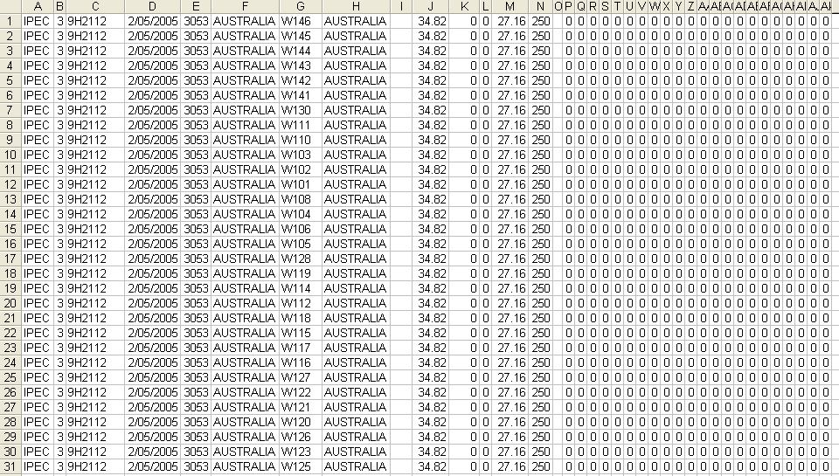

- Carrier ID
- Service ID. 2 = Local, 3 = Priority, 4 = Road Express
- Account Number
- Start Date
- From Postcode
- From Country
- To Postcode
- To Country
- Commodity Code – VALID ONLY FOR LOCAL
- Basic Charge
- Minimum Charge
- Basic Quantity
- Rate
- Cubic Ratio

IGNORE ALL OTHER FIELDS

